**A Mini Project Report**

**On**

**STUDY ON AIR SUSPENSION SYSTEM**

Submitted in partial fulfilment of the requirements

For the award of the degree of

**BACHELORS OF TECHNOLOGY**

**IN**

**MECHANICAL ENGINEERING**

**By**

**B.LAKSHMI GANESH (11R21A0369)**

**P.PRUDHVI RAJ (11R21A0395)**

**SK.WASIL (11R21A03A7)**

**Y.PRABHU KUMAR (11R21A03B7)**

**Under the esteemed guidance of**

**MS. N.ANURADHA** M.Tech.

Assoc.Professor

Dept of Mechanical Engineering

**At**



**MLR Institute of Technology**

1. **(Approved by AICTE and Affiliated to JNTU, Hyderabad)**
2. Laxman Reddy Avenue, Dundigal, QutbullapurMandal, Hyderabad-43.R.R.Dist.

**2014-15**

**Affiliated to**

**Jawaharlal Nehru Technological University**

**Kukatpally, Hyderabad-85.**

1. 
2. **(Approved by AICTE and Affiliated to JNTU, Hyderabad)**
3. Laxman Reddy Avenue, Dundigal, QutbullapurMandal, Hyderabad-43.R.R.Dist.

**2014-2015**

**CERTIFICATE**

This is to certify that the Mini Project report entitled “**STUDY ON AIR SUSPENSION SYSTEM** “is the bonafide work carried out and submitted by

**B.LAKSHMI GANESH (11R21A0369)**

**P.PRUDHVI RAJ (11R21A0395)**

**SK.WASIL (11R21A03A7)**

**Y.PRABHU KUMAR (11R21A03B7)**

To the Department of Mechanical Engineering, MLR Institute of Technology Hyderabad, Inpartial fulfilment for the award of**BACHELOR OF TECHNOLOGY IN MECHANICAL ENGINEERING**during the academic year 2014-2015.

**Internal Guide. Head of Department.**

**MS. N. ANURADHA** M.Tech. **Dr. A. SIVA KUMAR** Ph.D.

Assoc .Professor . Professor& Head

Dept of Mechanical Engineering. Dept of Mechanical Engineering

**INTERNAL EXAMINER. EXTERNAL EXAMINER.**

**ACKNOWLEDGEMENT**

The satisfaction and euphoria that accompany the successful completion of any task would be incomplete without the mention of people who made it possible, whose constant guidance and encouragement crowned our efforts with success. It is a pleasant aspect that I have now the opportunity to express my guidance for all of them.

I thankful to Principal**Dr. P. BHASKAR REDDY**, M.Tech. Ph.D., M.I.S.T.Eof MLR Institute of Technology for helped me to undergo project work as a part of university curriculum.

My special thanks**to Dr. A. SIVA KUMAR** M.Tech., Ph.DProfessor& Head in Mechanical Department and **MS.N.ANURADHA**M.Tech., Assoc.Professor in Mechanical Department for guiding me in the right way to complete my project in the right time.

I am thankful to **Mr. M. RAJA SEKHAR REDDY**Secretary of Technology for accepting me and providing me with an opportunity to do of MLR Institute a project in their esteemed organization.

We would like to thank our internal project mates and department professorsfor their full-fledged guidance and giving courage to carry out the project.

I am very much thankful to one and all that helped me for the successful completion of my project.

**DECLARATION**

I hereby declare that the entire work embodied in this project entitled**"STUDY ON AIR SUSPENSION SYSTEM”**being submitted in partial fulfillment of the academic requirement in IV Year II-semester as a record of the bonafide work carried out by me. No part of it has been submitted for the award of any degree or diploma at any other university or institution.

With regards,

1. **B.LAKSHMI GANESH (11R21A0369)**
2. **P.PRUDHVI RAJ (11R21A0395)**
3. **SK.WASIL (11R21A03A7)**
4. **Y.PRABHU KUMAR (11R21A03B7)**

**ABSTRACT**

Air ride suspension carries the load on each axle with a pressurized air bag much like a high pressure balloon. Air ride suspension systems have been in common use for over forty years and have proven to provide the smoothest and most shock-free ride of any known vehicle suspension system. Modern air bags are constructed using the same methods as a tire by using high strength cords which are then encapsulated in rubber. These units are very durable in service and have a proven life of many years.

In addition to providing extremely smooth ride quality, air ride suspension also provides other important features. First, the system automatically adjusts air pressure in the air bag so that the trailer always rides at the same height, whether lightly loaded or heavily loaded. This allows the suspension system to always provide the maximum usable wheel travel independent of trailer load. In addition, the higher air bag pressure associated with higher trailer loads automatically provides a stiffer suspension which is exactly what is required for a smooth ride. The lower air bag pressure for lightly loaded conditions automatically provides for a softer suspension, thus providing the same ride quality for all trailer loading conditions. Since each axle is independently supported by its own air bag, the air ride suspension is a truly, fully independent suspension system.

The automatic control of the air bag pressure is accomplished by a solid state electronic control system specifically designed and packaged for vehicle use. This system continuously monitors the "ride height" of the trailer suspension and increases air pressure if the ride height is too low, by turning on an on-board air compressor. The air compressor stops automatically when the proper ride height is reached. If the ride height is too high, an automatic vent valve vents excess air pressure and stops venting when the proper ride height is reached. All required electrical power is provided by a 12 volt battery contained in the trailer equipment compartment.

**TABLE OF CONTENTS:**

**ABSTRACT**

**TABLE OF CONTENS**

**LIST OF FIGURES**

**CHAPTER – 1 INTRODUCTION (10-16)**

1.1 Suspension system

1.2 Types of suspension system

1.3 Objective

1.3.1 Vehicle axis system

**CHAPTER – 2 LIERATURE RIVEW (17-24)**

2.1 Background

2.2 Issued journals and documents

**CHAPTER – 3 SUSPENSION SYSTEM (25-32)**

3.1 Types of suspension systems

3.1.1 Independent suspension system

3.1.2 Hydrolastic suspension system

3.1.3 Air suspension system

3.1.4 Conventional suspension system

**CHAPTER – 4 AIR SUSPENSION SYSTEM (33-34)**

4.1 Air suspension system

4.2 Air suspension system lay out

**CHAPTER 5 – DESIGN TO STAY O ROAD (35-41)**

5.1 Air suspension system design to stay on road

5.2 Square and round axle beams

5.3 Pneumatic control kit

5.4 Axle lifts

5.5 Operations &and adjustments of suspension systems

**CHAPTER – 6 TYPES OF AIR SUSPENSION SYSTEMS (42-45)**

6.1 Heavy duty air suspension systems

6.1.1 Features and benefits of air heavy duty air suspension systems

6.2 Light duty of air suspension systems

6.2.1 Features and benefits light air suspension systems

**CHAPTER – 7 CHARECTERISTICS OF COMPONENTS (46-49)**

7.1 Safety and components

7.2 Quality and features of components in system

**CHAPTER – 8 BENFITS AND LIMITATIONS OF**

**AIR SUSPENSION SYSTEMS (50-51)**

**CHAPTER – 9 CONCLUSIONS (52)**

**REFERENCES (53-54)**

**LIST OF FIGURES**

**CHAPTER 1**

Fig 1.1 Suspension system lay out 10

Fig 1.2 Conventional suspension system 11

Fig 1.3 Independent suspension system 12

Fig 1.4 Hydrolastic suspension system 13

Fig 1.4 Air suspension system 14

Fig 1.6 Vehicle axis system 16

**CHAPTER 2**

Fig 2.1 First air suspension by George Messier 17

Fig 2.2 Air suspension of four separate air springs 18

Fig 2.3 Air suspension by Cadillac in 1984 19

**CHAPTER 3**

Fig 3.1 Vehicle with suspension system 25

Fig 3.2 Independent suspension system 27

Fig 3.3 Hydrolastic suspension system 29

Fig 3.4 Air suspension system 30

Fig 3.5 Conventional suspension system 32

**CHAPTER 4**

Fig 4.1 Vehicle with air suspension 33

Fig4.2 Air suspension lay out 34

**CHAPTER 5**

Fig 5.1 Air suspension on road 35

Fig 5.2 Design of air suspension 36

Fig 5.3 Pneumatic control kit 38

Fig 5.4 Axle lifts 40

Fig 5.5 Operations and adjustments 41

**CHAPTER 6**

Fig 6.1 Heavy duty air suspension system 43

Fig 6.2 Light duty suspension system 44

**CHAPTER 7**

Fig 7.1 Components of air suspension system 46

Fig 7.2 Air suspension system 49

1. **INTRODUCTION**

**1.1 What is suspension system?**

* Suspension is the term given to the system of springs, shock absorbers and linkages that connects a vehicle to its wheels
* Serve a dual purpose – contributing to the car's handling and braking.
* Protects the vehicle itself and any cargo or luggage from damage and wear

SUSPENSION SYSTEM – LAY OUT

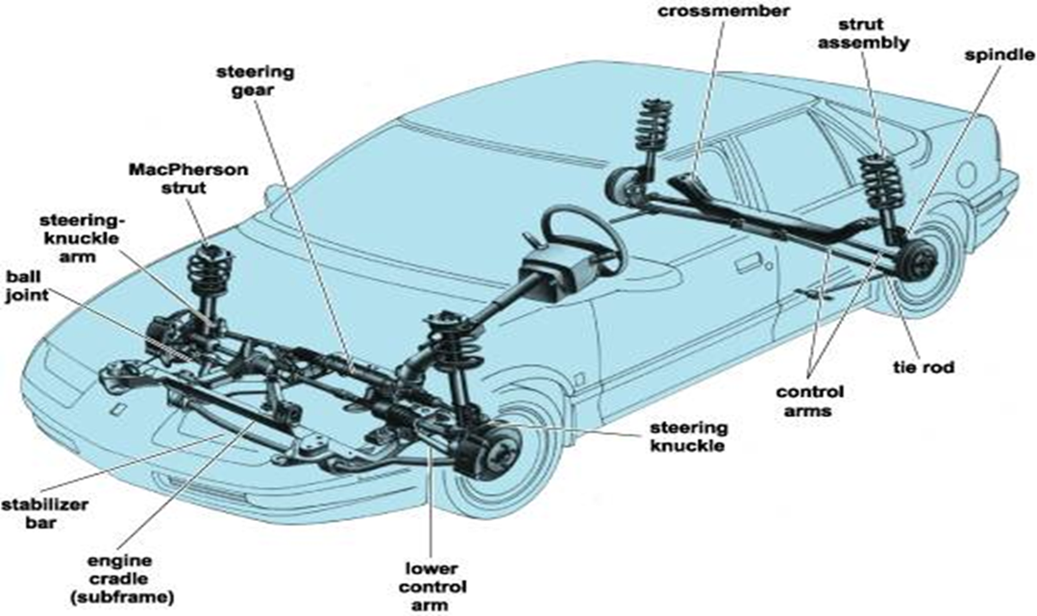

**Fig.1.1 SUSPENSION SYSTEM LAY OUT**

**1.2 DIFFERENT SUSPENSION SYSTEMS:**

1. Conventional suspension system
2. Independent suspension system
3. Air suspension system
4. Hydro elastic suspension system

**Conventional suspension system:**

1. Two wheels are mounted on either side of the rigid axle
2. When one wheel encounters the bump, both the wheel do not execute parallel up and down motion
3. So it gives rise to gyroscopic effect and wheel wobble
4. Rear driving wheels mounted on live axle suspended by laminated leaf springs and shock absorbers

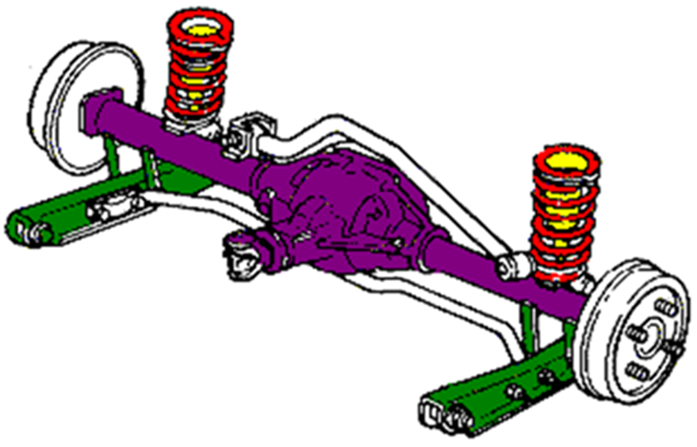

**FIG 1.2 CONENTIONAL SUSPENSION SYSTEM**

**Independent suspension system**

1. Both the front and the rear wheel are utilized
2. Design incorporated in the front wheels
3. One wheel goes down, the other wheel does not have much effort

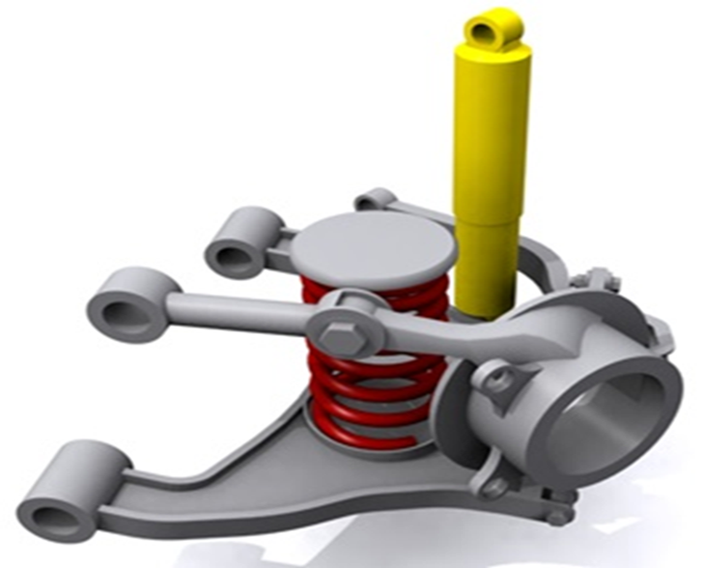

**FIG 1.3 INDEPENDET SUSPENSION SYSTEM**

**Hydro elastic suspension system**

1. A system where the front and rear suspension systems were connected together in order to better level the car when driving.
2. The front and rear suspension units have Hydrolastic displacers, one per side.
3. These are interconnected by a small bore pipe. Each displacer incorporates a rubber spring.
4. Damping of the system is achieved by rubber valves.

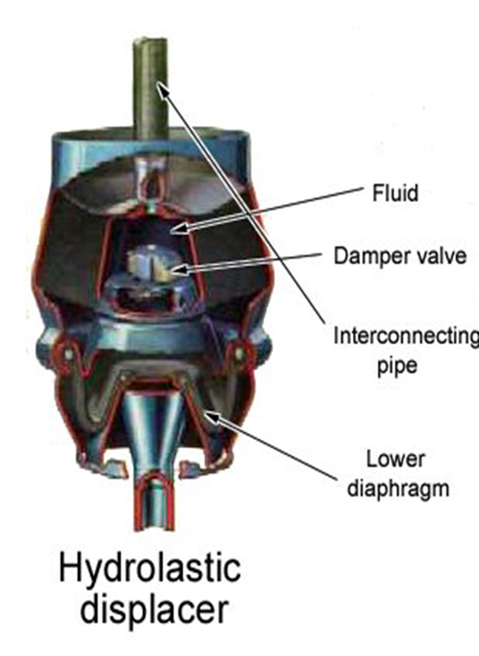

**FIG 1.4 HYDRO ELASTIC SUSPENSION SYSTEM**

1. When the front wheel encounter bumps, the piston moves upwards pressurizing the fluid to enter into the rear unit.
2. Hydro elastic was eventually refined into Hydra gas suspension.......

**Air suspension**

1. Comprises of compressor, supplying air to air tank
2. Pressure maintained – 5.6 to 7 kg/sq.m
3. Air bags – on each wheel
4. As load applied, air bags compressed actuating the leveling valve.
5. Airs from the tank fills the compressed air bag & hence raise the level of the frame.
6. Air from air bag gets released as load on chassis decreases.

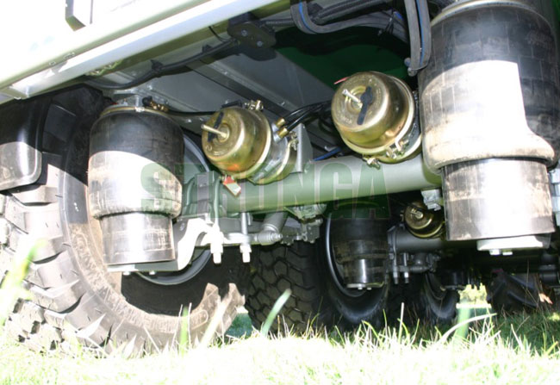

**FIG 1.5 AIR SUSPENSION SYSTEM**

**1.3 OBJECTIVE:**

* **To provide good ride and handling performance**

1. vertical compliance providing chassis isolation
2. ensuring that the wheels follow the road profile
3. very little tire load fluctuation

* **To ensure that steering control is maintained during maneuvering**

1. wheels to be maintained in the proper position wrt road surface

* **To ensure that the vehicle responds favorably to control forces produced by the tires during**

1. Longitudinal braking.
2. Accelerating forces.
3. Lateral cornering forces and braking and accelerating torques.
4. This requires the suspension geometry to be designed to resist squat, dive and roll of the vehicle body.

* **To provide isolation from high frequency vibration from tire excitation**

1. Requires appropriate isolation in the suspension joints.
2. Prevent transmission of ‘road noise’ to the vehicle body.

**1.3.1 Vehicle Axis system**

1. Un-sprung mass.
2. Right-hand orthogonal axis system fixed in a vehicle.
3. X-axis is substantially horizontal, points forward, and is in the longitudinal plane of symmetry.
4. Y-axis points to driver's right and
5. Z-axis points downward.
6. Rotations:
   1. A yaw rotation about Z-axis.
   2. A roll rotation about X-axis.
   3. A pitch rotation about Y-axis.



SAE vehicle axes

**FIG 1.6 VEHICLE AXIS SYSTEM**

1. **LITERATURE REVIEW**

**2.1 BACKGROUND:**

In 1901 William W. Humphreys patented a 'Pneumatic Spring for Vehicles'. The design consisted of a left and right air spring longitudinally channeled nearly the length of the vehicle. The channels were con-caved to receive two long pneumatic cushions. Each one was closed at one end and provided with an air-valve at the other end.

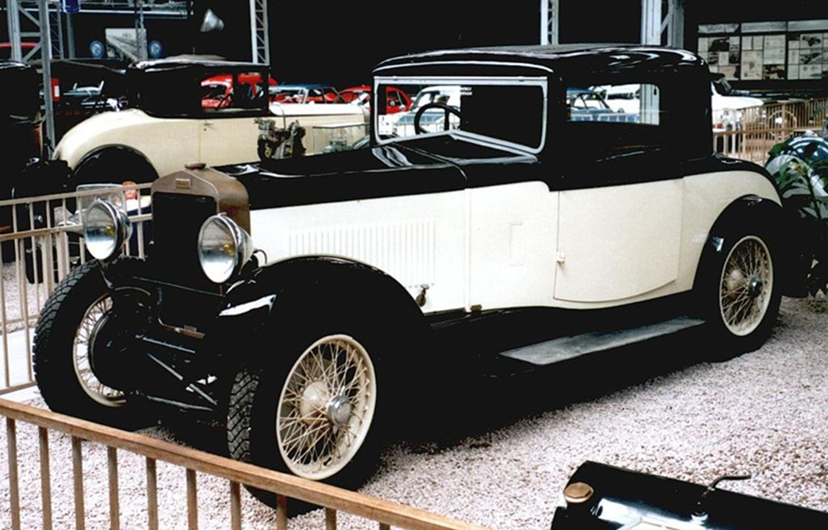

**FIG 2.1- The first air suspension system assembled vehicle by GEORGE MESSIER**

**It consists of longitudinal air springs nearly the length of the vehicle**

From 1920, George Messierprovided aftermarketpneumatic suspension systems. His own 1922-1930 Messier automobiles featured a suspension "to hold the car aloft on four gas bubbles.

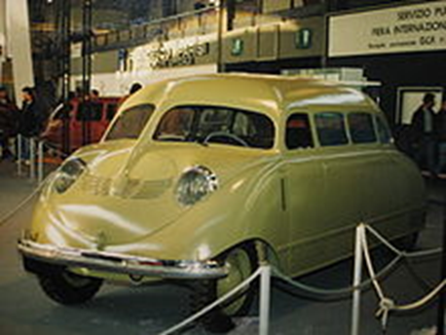

**FIG 2.2- The second vehicle with air suspension system of four separate air springs**

**(Air bags) in the year 1946**

In 1946, William Bushnell Stoutbuilt a prototype Stout Scarab that featured numerous innovations that included a four-wheel independent air suspension system.

General Motors introduced air suspension as standard equipment on the new 1957 Cadillac Eldorado Brougham. An "Air Dome" assembly at each wheel included sensors to compensate for uneven road surfaces and to automatically maintain the car's height. For 1958 and 1959, the system continued on the Eldorado Brougham, and was offered as an extra cost option on other Cadillac’s.

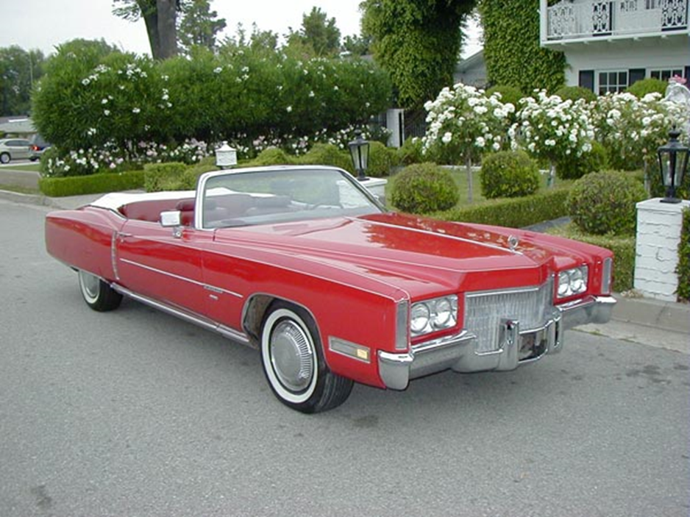

**FIG 2.3- It is the CADILLAC ELDORADO BROUGHAM vehicle which offered sir suspension system since 1957.**

**They introduced the air suspension as the standard equipment,**

**CADILLAC offered this till 1984.**

In 1958, Buick introduced an optional "Air-Poised Suspension" with four cylinders of air (instead of conventional coil springs) for automatic leveling, as well as a "Bootstrap" control on the dashboard to raise the car 5.5 inches (139.7 millimeters) for use on steep ramps or rutted country roads, as well as for facilitating tire changes or to clean the whitewall tires. For 1959, Buick offered an optional "Air Ride" system on all models that combined "soft-rate" steel coil springs in the front with air springs in the rear.

An optional air suspension system was available on the 1958 and 1959 Rambler Ambassadors, as well as on all American Motors "Cross Country" station wagonmodels. The "Air-Coil Ride" utilized an engine-driven compressor, reservoir, air bags within the coil springs, and a ride-height control, but the $99 optional system was not popular and American Motors (AMC) discontinued it for 1960.

Only Cadillac continued to offer air suspension through the 1960 model year, where it was standard equipment on the Eldorado Seville, Biarritz and Brougham.

Air suspension would not return to standard production on American-built cars until Lincoln Motor Company introduced it as standard equipment on the Lincoln Continental Mark VII in the 1984 model year.

* 1. **ISSUED JOURNALS AND DOCUMENTS**

1. ***Hyunsup Kim; Hyeongcheol Lee "Height and Leveling Control of Automotive Air Suspension System Using Sliding Mode Approach", Vehicular Technology, IEEE Transactions on, on page(s): 2027 - 2041 Volume: 60, Issue: 5, Jun 2011.***

Electronically controlled air suspension systems have been used in vehicles to improve ride comfort and handling safety by adjusting vehicle height. This paper proposes a new nonlinear controller to adjust the height of the vehicle sprung mass (height control) and to regulate the roll and pitch angles of the vehicle body (leveling control) by an air suspension system. A sliding mode control algorithm is designed to improve the tracking accuracy of the control and to overcome nonlinearities and uncertainties in the air suspension system. A mathematical model of the air suspension system is formulated in a nonlinear affine form to describe the dynamic behavior of the system and to derive the control algorithm. The sliding mode observer is also designed to estimate the pressures inside four air springs. The effectiveness and performance of the proposed control algorithm are verified by simulations and actual vehicle tests.

1. ***Donggil Ha; Hyunsup Kim; Hyeongcheol Lee "Height sensor fault diagnosis for electronic air suspension (EAS) system", Industrial Electronics, 2009. ISIE 2009. IEEE Internationa .***

This paper presents a method to diagnose the height sensor faults of the electronic air suspension system. The height sensor faults are detected based on the analysis of the geometrical relationship between the sensors. The fault isolation is performed by the roll angle and pitch angle signals which can be estimated using other sensor signals such as acceleration signals. The fault detection and isolation method proposed in this paper are verified by the simulations and vehicle test.

1. ***Hyunsup Kim; Hyeongcheol Lee "Fault-Tolerant Control Algorithm for a Four-Corner Closed-Loop Air Suspension System", Industrial Electronics, IEEE Transactions on, on page(s): 4866 - 4879 Volume: 58, Issue: 10, Oct. 2011.***

This paper presents a new systematic control and fail-safe design methodology for a four-corner closed-loop air suspension (CLAS) system. The proposed control algorithm consists of “system control” determining the target heights of the four corners of the vehicle body from driving conditions and from the driver's commands and “actuator control” achieving the target heights by controlling actuators. A sliding-mode control with phase-compensated feedback signal is applied as the main part of the system control. With the use of the sliding-mode control, the proposed system control can improve control accuracy and robustness against delays and disturbances as well as reduce the bounce oscillation of the vehicle body. This paper proposes a stepwise height control as the actuator control to overcome the limited power of the production CLAS system. The stepwise height control adjusts the front corners and the rear corners alternately until the four corners reach their corresponding target heights. A fail-safe algorithm (FA) is also proposed to provide the fault detection (FD), diagnosis, and management of the CLAS. In particular, a model-based FD method for the pressure sensor and the height sensors, which are critical components in the CLAS control system, has been proposed. A mathematical model of a CLAS system is developed for algorithm development and simulation. The proposed control algorithm and FA are verified by simulations and actual vehicle tests.

1. ***Inseob Jang; Hyunsup Kim; Hyeongchul Lee; Sangsoo Han "Height control and failsafe algorithm for closed loop air suspension control system", Control, Automation and Systems, 2007. ICCAS '07. International Conference on, on page(s): 373 – 378.***

This paper presents the control and failsafe algorithm of the closed loop air suspension system on the basis of analyzing the air suspension system and understanding the vehicle dynamics. The control algorithm determines target heights from driving conditions and driver's commands and actuators including a compressor, two reversing valves, and four air spring valves to achieve the target heights. The failsafe algorithm determines the type of faults and enables appropriate failsafe actions depending on the type of faults. To verify suggested control and failsafe algorithm, the simulations and the vehicle tests are conducted.

1. ***Aburaya, T.; Kawanishi, M.; Kondo, H.; Hamada, T. "Development of an electronic control system for active suspension ", Decision and Control, 1990. Proceedings of the 29th IEEE Conference on, on page(s): 2220 - 2225 vol.4.***

The Toyota active control suspension is the first system for passenger cars that actively controls suspension by means of a hydro pneumatic system. The authors describe the electronic control unit (ECU), which executes high-speed and highly-accurate processing, and the high-resolution sensors developed for the Toyota Celica's active control suspension. The ECU has two custom C-MOS 8-b single-chip microcomputers (main-CPU and sub-CPU). The main-CPU primarily processes basic control operations, while the sub-CPU processes input and output signals. The acceleration (G) sensor with amorphous-metal-thin-film distortion gauges detects both longitudinal and lateral acceleration of the vehicle. There are two kinds of height sensors, contact-free magnetic angle sensors with a Hall element and magneto resistive elements for detecting the suspension stroke of each wheel. There are also two types of pressure sensors, those that have a silicon piezoresistive gauge and those that have an amorphous-metal-thin-film distortion gauge, for detecting the cylinder and system pressure.

**3. SUSPENSION SYSTEM**

**SUSPENSION SYSTEM:-**

Suspension is the term given to the system of springs, shock absorbers and linkages that connects a vehicle to its wheels. Suspension systems serve a dual purpose - contributing to the car's road holding handling and braking for good active safety and driving pleasure, and keeping vehicle occupants comfortable and reasonably well isolated from road noise, bumps, and vibrations, etc. These goals are generally at odds, so the tuning of suspensions involves finding the right compromise. It is important for the suspension to keep the road wheel in contact with the road surface as much as possible, because all the forces acting on the vehicle do so through the contact patches of the tires. The suspension also protects the vehicle itself and any cargo or luggage from damage and wear. The design of front and rear suspension of a car may be different.

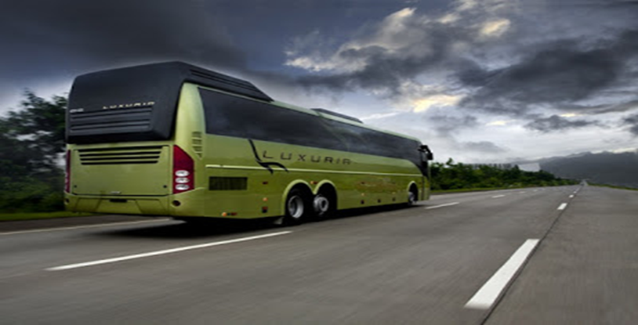

**FIG 3.1 VEHICLE WITH SUSPENSION SYSTEM**

**3.1 TYPES OF SUSPENSION SYSTEM**

1. Conventional suspension system

2. Independent suspension system

3. Air suspension system

4. Hydro elastic suspension system

**3.1.1 INDEPENDENT SUSPENSION SYSTEM**

Independent suspension is a broad term for any automobile suspension system that allows each wheel on the same axle to move vertically (i.e. reacting to a bump in the road) independently of each other. This is contrasted with a beam axle or deDion axle system in which the wheels are linked – movement on one side effects the wheel on the other side. Note that "independent" refers to the motion or path of movement of the wheels/suspension. It is common for the left and right sides of the suspension to be connected with anti-roll bars or other such mechanisms. The anti-roll bar ties the left and right suspension spring rates together but does not tie their motion together.

Most modern vehicles have independent front suspension (IFS). Many vehicles also have an independent rear suspension (IRS). IRS, as the name implies, has the rear wheels independently sprung. A fully independent suspension has an independent suspension on all wheels. Some early independent systems used swing axles, but modern systems use Chapman or MacPherson struts, trailing arms, multilink, or wishbones.

Independent suspension typically offers better ride quality and handling characteristics, due to lower unspring weight and the ability of each wheel to address the road undisturbed by activities of the other wheel on the vehicle. Independent suspension requires additional engineering effort and expense in development versus a beam or live axle arrangement. A very complex IRS solution can also result in higher manufacturing costs.

The key reason for lower unsprung weight relative to a live axle design is that, for driven wheels, the differential unit does not form part of the unsprung elements of the suspension system. Instead it is either bolted directly to the vehicle's chassis or more commonly to a sub frame.

The relative movement between the wheels and the differential is achieved through the use of swinging driveshaft’s connected via universal (U) joints, analogous to the constant-velocity (CV) joints used in front wheel drive vehicles.

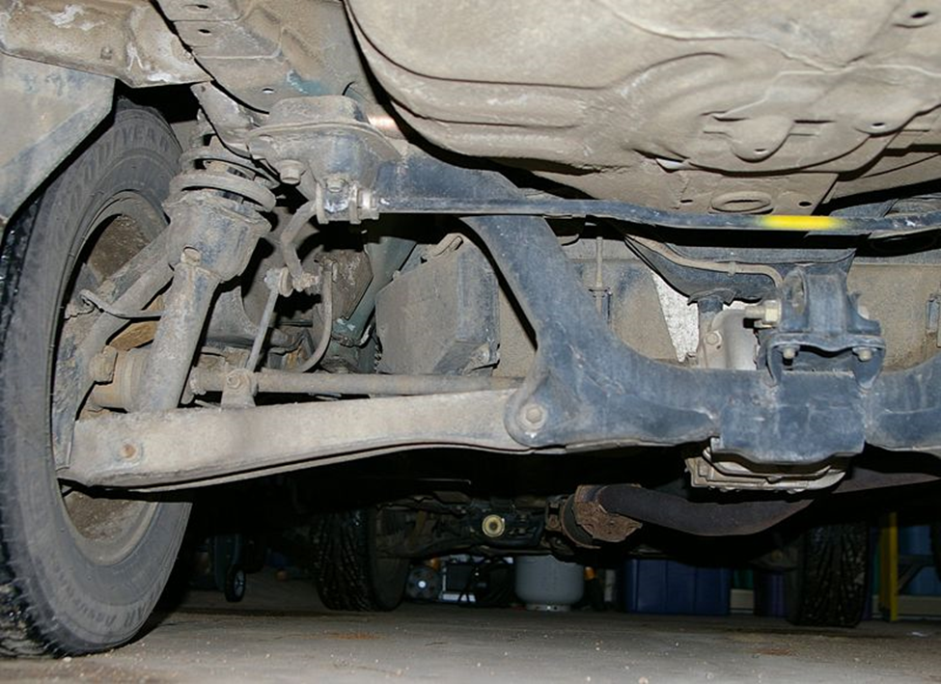

**FIG 3.2 INDEPENDENT SUSPENSION SYSTEM**

**3.1.2 Hydrolastic Suspension**

A system where the front and rear suspension systems were connected together in order to better level the car when driving.

The principle is simple. The front and rear suspension units have Hydrolastic displacers, one per side. These are interconnected by a small bore pipe. Each displacer incorporates a rubber spring (as in the Moulton rubber suspension system), and damping of the system is achieved by rubber valves. So when a front wheel is deflected, fluid is displaced to the corresponding suspension unit. That pressurizes the interconnecting pipe which in turn stiffens the rear wheel damping and lowers it. The rubber springs are only slightly brought into play and the car is effectively kept level and freed from any tendency to pitch. That's clever enough, but the fact that it can do this without hindering the full range of motion of either suspension unit is even cleverer, because it has the effect of producing a soft ride.

But what happens when the front and rear wheels encounter bumps or dips together? One cannot take precedent over the other, so the fluid suspension stiffens in response to the combined upward motion and, while acting as a damper, transfers the load to the rubber springs instead, giving a controlled, vertical, but level motion to the car.

Remember I said the units were connected with a small bore pipe? The restriction of the fluid flow, imposed by this pipe, rises with the speed of the car. This means a steadier ride at high speed, and a softer more comfortable ride at low speed.

Hydrolastic suspension is hermetically sealed and thus shouldn't require much, if any, attention or maintenance during its normal working life. Bear in mind that hydrolastic suspension was introduced in 1964 (on the prototype BMC ADO16) and you'd be lucky to find a unit today that has had any work done to it.

The image here shows a typical lateral installation for hydrolastic rear suspension. The suspension swing arms are attached to the main sub frame. The red cylinders are the displacer units containing the fluid and the rubber spring. The pipes leading from the units can be seen and they would connect to the corresponding units at the front of the vehicle.

Hydrolastic suspension shouldn't be confused with Citroën's hydro pneumatic suspension. That system uses a hydraulic pump that raises and lowers the car to different heights. Sure it's a superior system but it's also a lot more costly to manufacture and maintain. That's due in part to the fact that they don't use O-rings as seals; the pistons and bores are machined to incredible tolerances (microns), that it makes seals unnecessary.

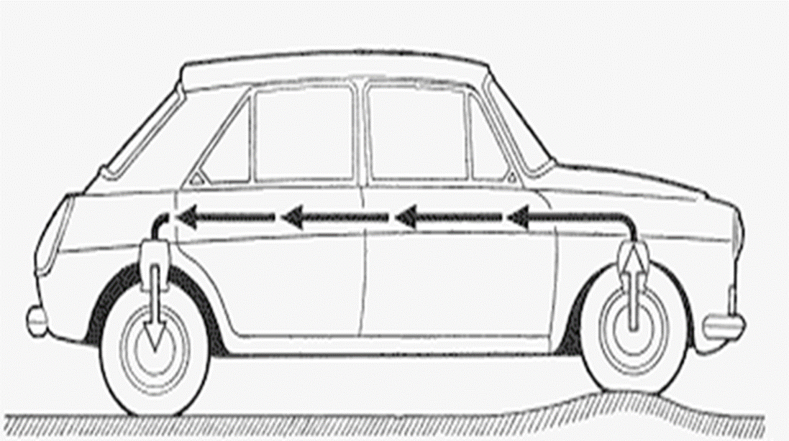

**FIG 3.3 HYDROLASTIC SUSPENSION SYSTEM**

**3.1.3 AIR SUSPENSION:**

It offers a comprehensive range of trailer air suspensions designed to perform under various operating conditions, from low tare weight configurations for highway applications to heavy duty off-road models up to 14 tons per axle capacity. Air suspension systems are available to suit various tire sizes, trailer lengths and widths. It was first to introduce a fully integrated axle, air suspension and braking system – all designed and engineered to work in harmony with unsurpassed component compatibility and performance.

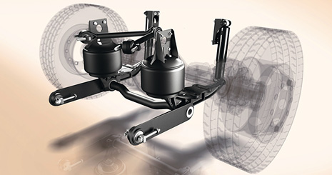

**FIG 3.4 AIR SUPENSION SYSTEM**

* + 1. **COVENTIONAL SUPENSION SYSTEM:**

The systems that which are in direct contact to the work or carrying a work traditionally are called active systems or conventional systems. Therefore the suspension system which carries a work in a traditional way is called conventional suspension system or an active suspension system.

The active suspension and adaptive suspension/semi-active suspension are types of automotive suspensions that controls the vertical movement of the wheels relative to the chassis or vehicle body with an onboard system, rather than in passive suspensions where the movement is being determined entirely by the road surface. Active suspensions can be generally divided into two main classes: pure active suspensions and adaptive/semi-active suspensions. While adaptive suspensions only vary shock absorber firmness to match changing road or dynamic conditions, active suspensions uses some type of actuator to literally raise and lower the chassis independently at each wheel.

These technologies allow car manufacturers to achieve a greater degree of ride quality and car handling by keeping the tires perpendicular to the road in corners, allowing better traction and control. An onboard computer detects body movement from sensors throughout the vehicle and, using data calculated by opportune control techniques, controls the action of the active and semi-active suspensions. The system virtually eliminates body roll and pitch variation in many driving situations including cornering, accelerating, and braking.

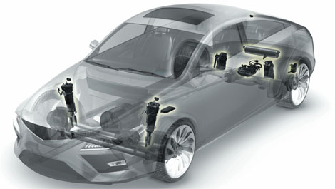

**Fig: 3.5 CONVENTIONAL SUSPENSION SYSTEM**

**4. AIR SUSPENSION SYSTEM**

* 1. **AIR SUSPENSION SYSTEM:-**

**“Air suspension is a derived part of suspension system which is broadly used in heavy vehicles like trucks, buses and in trains.”**

The purpose of air suspension is to provide a smooth, constant ride quality, but in some cases is used for sporty suspensions. Modern electronically controlled systems in automobiles and light trucks almost always feature self-leveling along with raising and lowering functions. Although traditionally called air bags or air bellows, the correct term is air spring (although these terms are also used to describe just the rubber bellows element with its end plates).

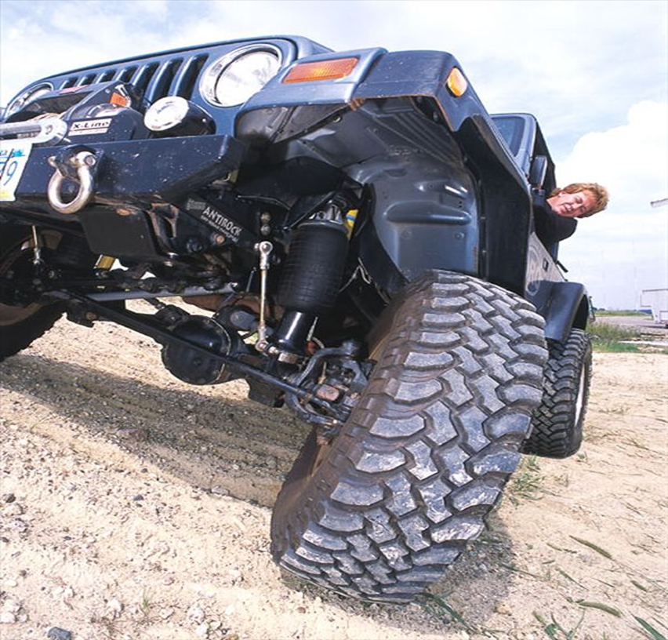

**FIG 4.1 VEHICLE WITH AIR SUSPENSION SYSTEM**

**4.2 AIR SUSPENSION LAYOUT**

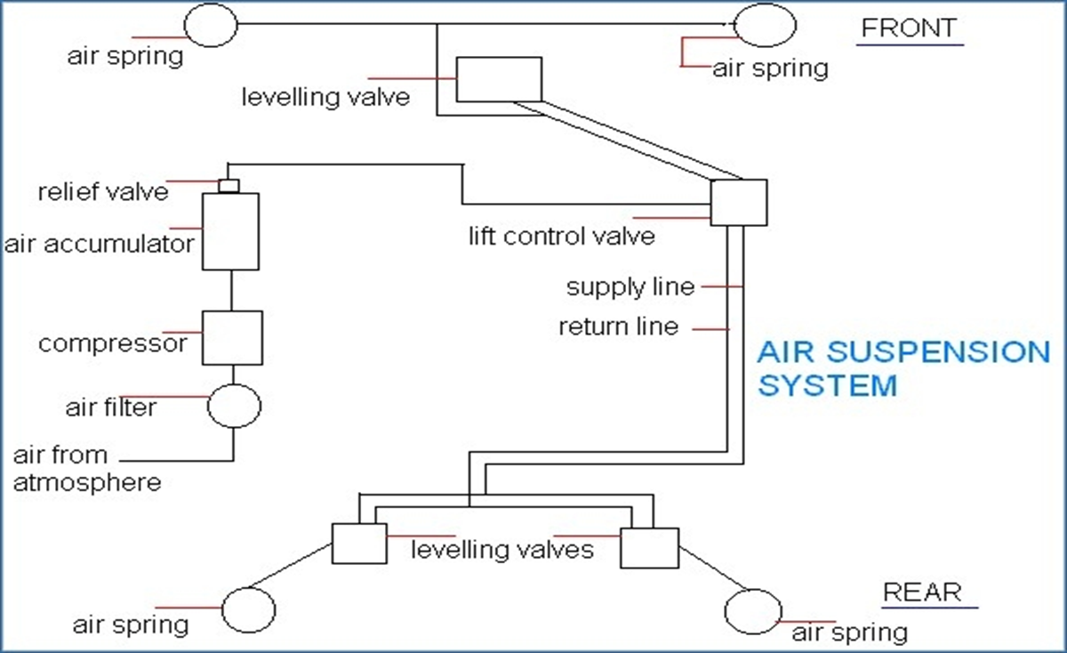

**FIG 4.2 AIR SUSPENSION LAY OUT**

**5. DESIGN -TO STAY ON ROAD**

**5.1 AIR SUSPENSION SYSTEM DESIGNED TO STAY ON ROAD:**

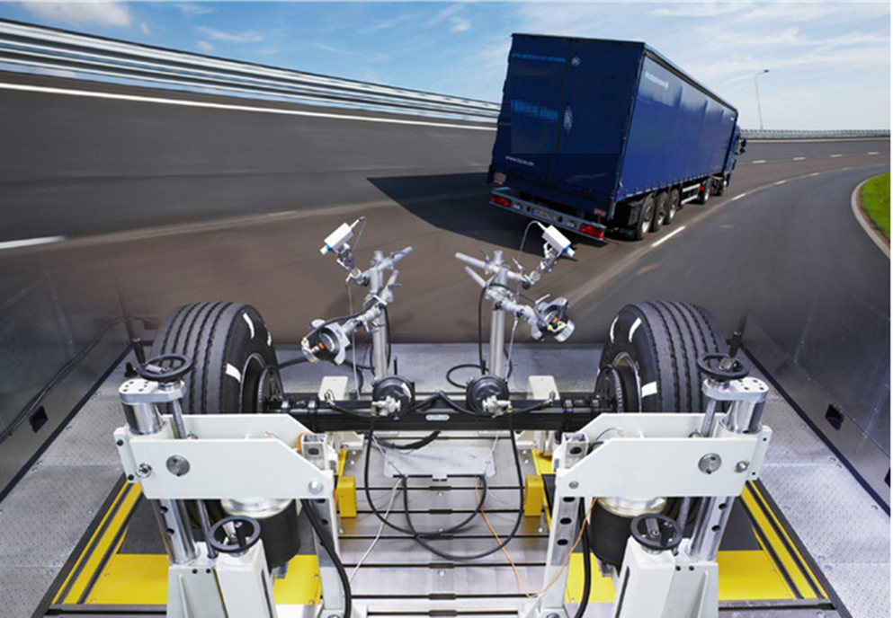

**FIG 5.1 AIR SUSPENSION SYSTEM ON ROAD**

**Precision, a meticulous approach:**

It offers a range of airbag suspension models which are optimized to suit a large variety of operating conditions. It suits highway conditions.

The Heavy Duty covers more extreme road conditions and for axles loads up to 12 tones. It also offers an extra heavy duty suspension with axle loads up to 14 tones for mining operations.

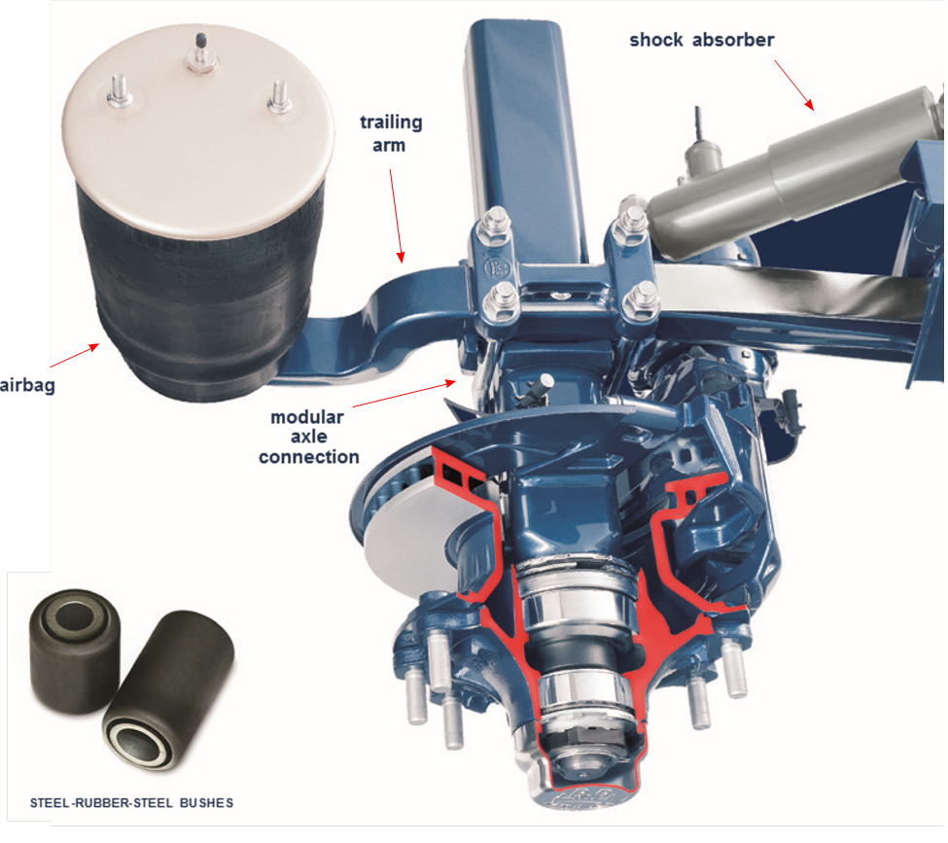

**FIG 5.2 DESIGN OF AIR SUSPENSION**

**5.2 SQUARE AXLE BEAMS**

Ongoing research and development at institutes and organization has resulted in the use of square axle beams with air suspensions. An axle beam needs to be able to withstand not only the bending stresses due to the applied load, but also the bending and torsional stress due to the brakes and air suspension trailing arms. A square section axle beam is more efficient in distributing these stresses, therefore it is stronger for any given axle beam weight when compared with a round beam. The square section axle beam gives the operator greater roll stability, better tracking and greater safety factors when compared to round beam axles.

STRENGTH OF WEIGHT RATIO:

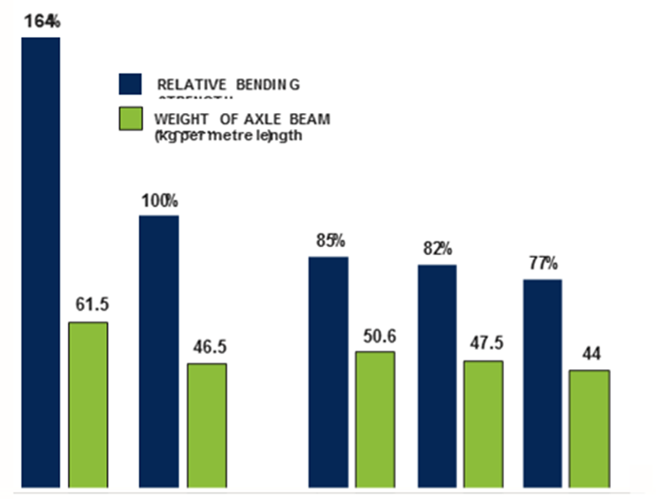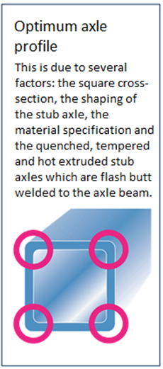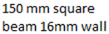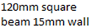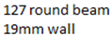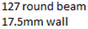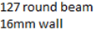

**Square Beam Round Beam**

**The Square Axle gives the best ‘Strength to Weight Ratio’ for Airbag Suspension applications.**

**5.3 PNEUMATIC CONTROL KIT:**

The Airbag Suspension pneumatic control system employs a single high flow height control valve to ensure pressure equalization giving a constant ride height for all load conditions. Air Suspensions are supplied with a complete pneumatic control kit.

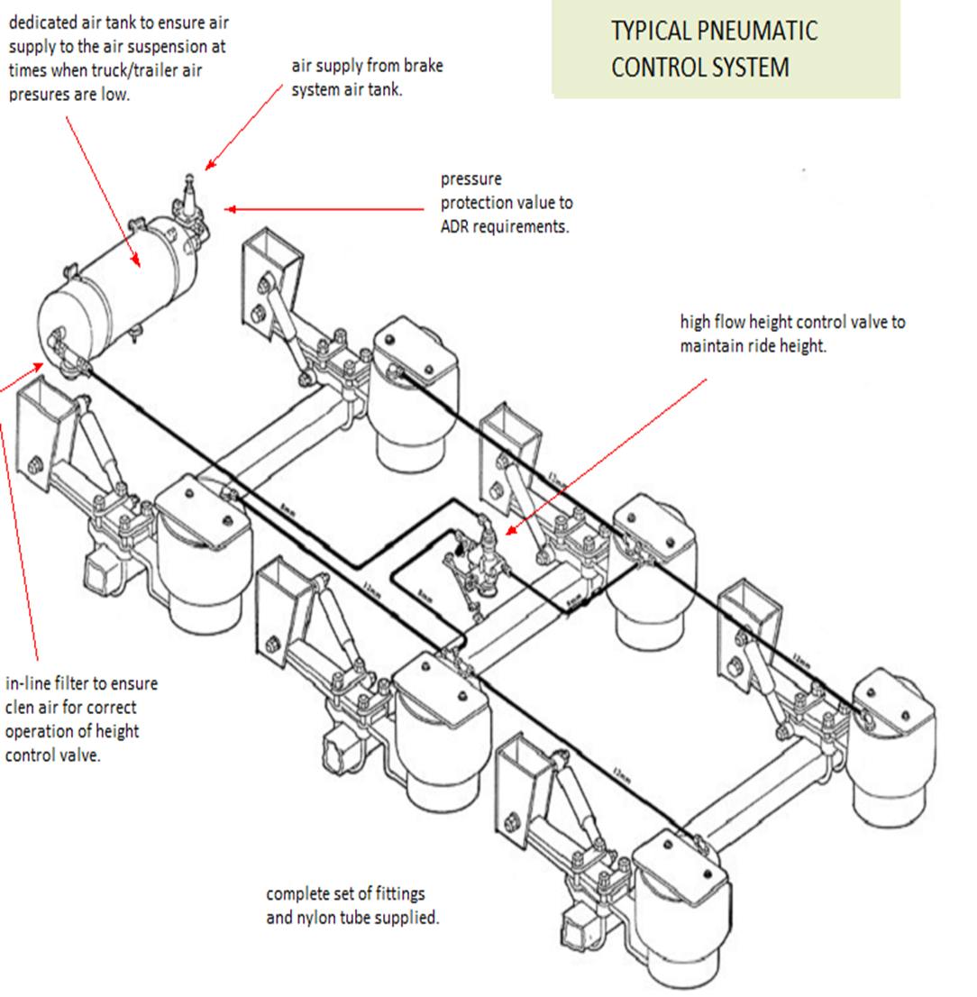

**FIG 5.3 PNEUMATIC CONTROL KIT**

**5.4 AXLE LIFT:**

As an option, multi-axle trailers can be equipped with an axle lift. Operators have found that the benefits of the Axle-Lift include reduced fuel consumption, improved brake balance when unladed and reduced tire wear.

The Axle-Lift Systems are available with ‘side-lift’, ‘centre-lift’ or double booster-style side lift configurations, to suit the particular trailer application and can be installed on up to two axles of the tri-group. All Axle-Lift Systems comply with current ADR requirements and are supplied as standard with fully automatic pneumatic controls which lifts and lowers the Lift Axle(s) at the legally prescribed axle loads. The system has an ‘off’ switch located in a lockable enclosure as stipulated by the ADRs.

When fitted to a trailer with EBS the Lift Axle(s) is controlled by the EBS and again is lifted and lowered automatically at the legally prescribed axle loads. An ‘off’ switch in a lockable enclosure is also provided. The Axle-Lift System is simple to use and can be fitted to most trailer airbag suspensions, in both the ‘Highway’ the on/off road ‘Heavy Duty’ range.

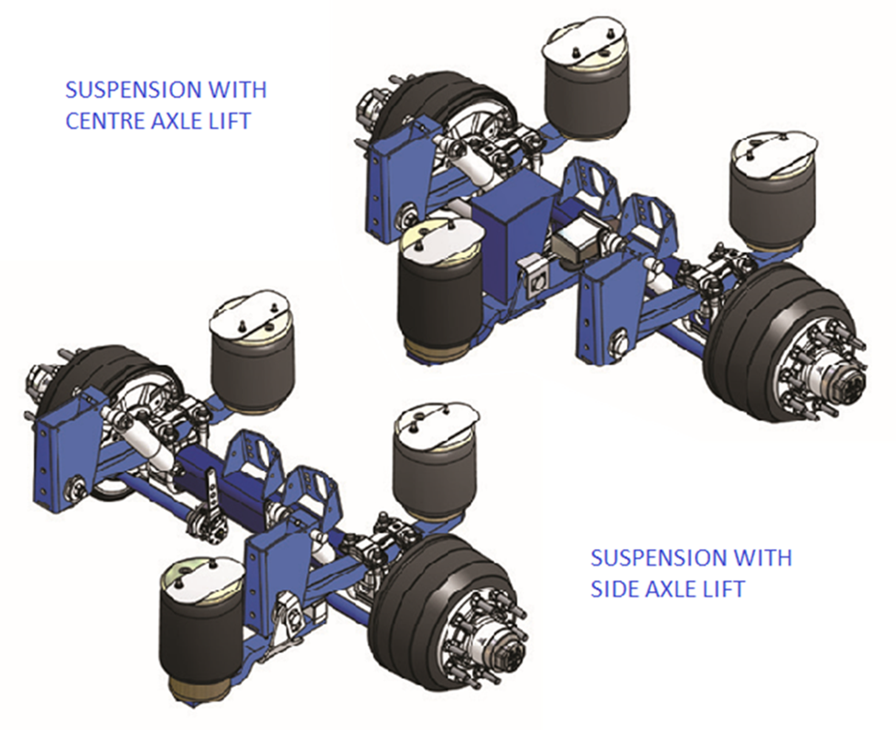

**FIG 5.4 AXLE LIFTS**

**5.5 OPERATIONS AND ADJUSTMENTS OF AIR SUSPENSION:**

**Raise and lower system:**

It offers a rise/lower valve system which enables the height of the trailer to be matched to various dock levels, saving costly loading/unloading times.

**Reset to ride:**

It also offers an optional ‘reset to ride’ raise/lower system, which automatically resets to ride height once the trailer brakes are activated. This function can be incorporated into the system when feted.

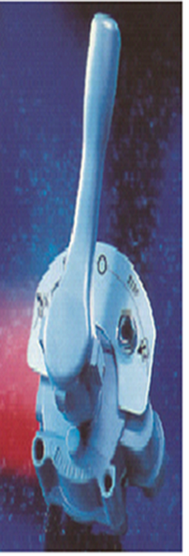

**FIG 5.5 OPERATION AND ADJUSTMENT**

**6. TYPES OF AIR SUSPENSION SYSTEMS**

**TYPES OF AIR SUSPENSIONS:**

Air suspension systems are categorized into two types:

1. Heavy duty air suspension system.
2. Light duty air suspension system.

**6.1 HEAVY DUTY AIR SUSPENSIONS**

The Heavy Duty airbag suspension range is well proven, and is recommended for on/ off road conditions. For decades the models have been refined to an almost ‘bullet-proof’ status in extreme operating conditions.

Heavy Duty airbag suspensions are characterized by double-leaf 100mm wide trailing arm springs, heavy duty fabricated hangers, cable catch straps and the large Type 36 airbags.

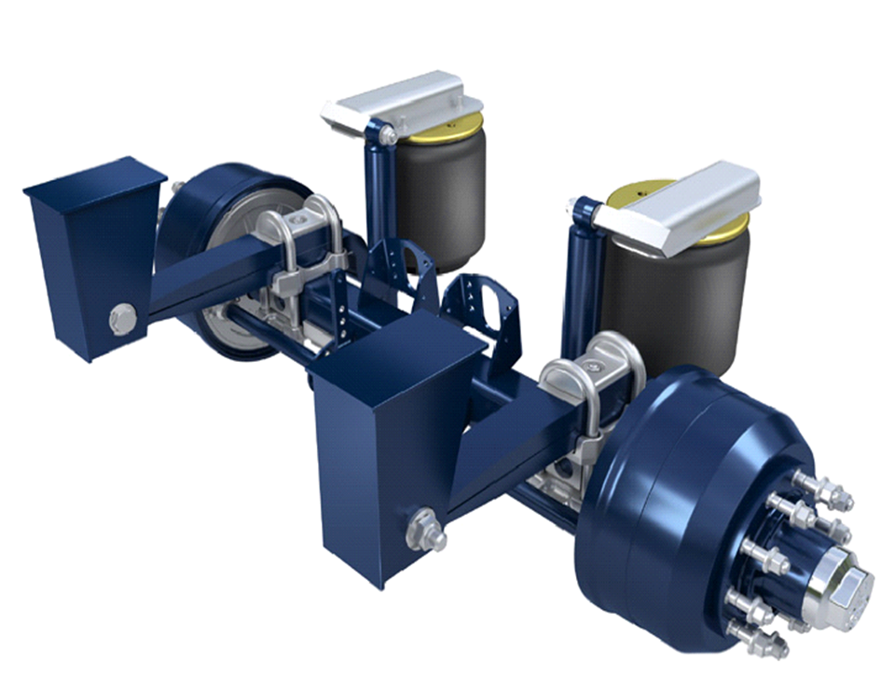

**FIG 6.1 HEAVY DUTY AIR SUSPENSION**

**6.1.1FEATURES AND BENFITS OF HEAVY DUTY AIR SUSPENSION SYSTEM:**

1. Robust design.
2. Excellent stability characteristics and optimum roll resistance.
3. Flexible trailing arm offers best possible wheel control, safer driving characteristics with reduced stress on the trailer chassis.
4. Highest driving comfort and sensitive ‘soft-ride’ handling of the cargo.
5. Easy to service - thanks to modular design.
6. Easy to install.
7. Reduced tire wear due to the axle control of the steel-rubber-steel bushes.
8. Optimum axle load equalization.
9. National off-the-shelf genuine spare parts for minimal downtime.

**6.2 LIGHT AIR SUSPENSION SYSTEM:**

Light air suspensions have highly efficient mono leaf 70mm wide trailing arm springs, pressed hangers, webbing sling axle restraints (wrapped around the shock absorbers) and are supplied as standard with 30K airbags. On most light suspensions models, cable catch straps and type 36 airbags are fixed.

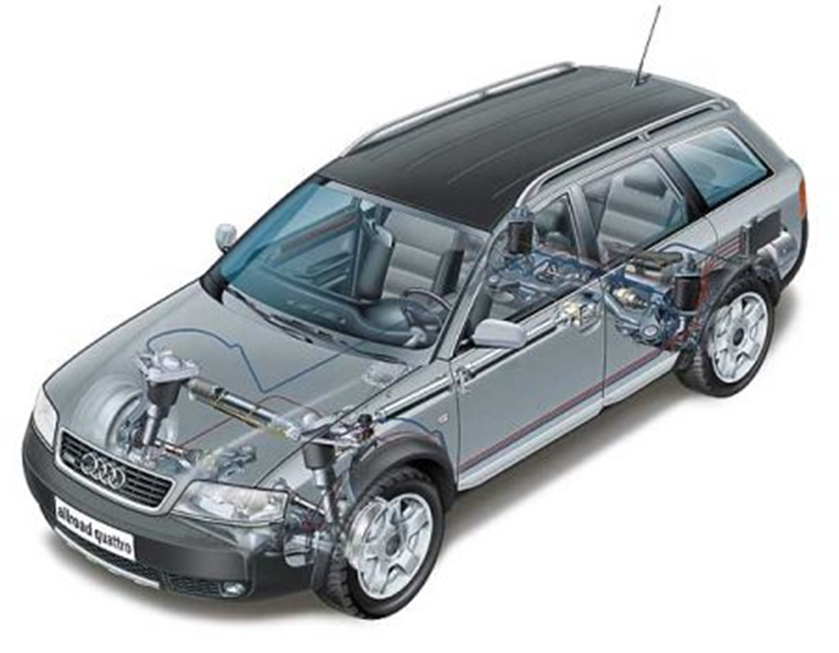

**FIG 6.2 LIGHT DUTY AIR SUSPENSION SYSTEM.**

**6.2.1 FEATURES AND BENFITS OF LIGHT DUTY AIR SUSPENSION SYSTEM:**

1. Less tare weight yet stronger components.
2. Greater roll stiffness than previous Highway Series suspensions thanks to the new trailing arm.
3. Flexible trailing arm offers best possible wheel control, safer driving characteristics with reduced stress on the trailer chassis.
4. Highest driving comfort and sensitive ‘soft-ride’ handling of the cargo.
5. Easy to service.
6. Easy to install - due to the narrow, straight hanger brackets.
7. Excellent stability characteristics and optimum roll resistance.
8. Reduced tyre wear due to the axle control of the steel-rubber-steel bushes.
9. Optimum axle load equalisation.
10. National off-the-shelf genuine spare parts for minimal downtime.

**7. CHARACTERISTICS OF COMPONENTS**

**7.1 SAFETY AND COMPONENTS:**

It sets the global standard for its uncompromising manufacture of premium products which satisfies the most exacting requirements in terms of quality and reliability. Genuine parts are available individually or in repair kits, which contain all required components.

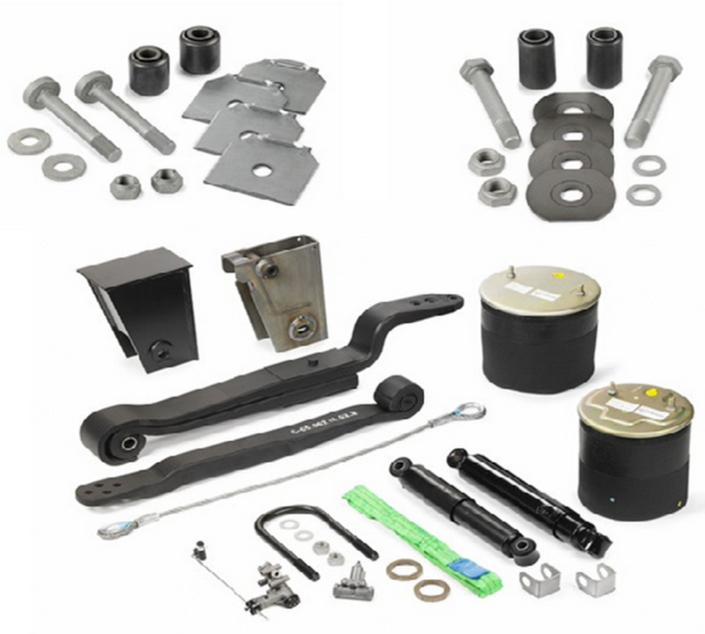

**FIG 7.1 COMPONENTS OF AIR SUSPENSION SYTEM**

**7.2 QUALITY AND FEATURES OF COMPONENTS IN SYSTEM:**

1. **Modular system:**

Airbag suspensions have been designed with the philosophy that equipment must have lowest possible whole-of-life costs. The similarities between suspensions and air suspensions are only superficial; the many differences are in the details of suspension component design, the small things that are all important when adding up the total cost of the running gear over the life of the vehicle.

1. **Soft ride characteristics:**

Because the airbags are fitted further behind the axle than with other suspensions, the ride characteristics of the trailer air suspension delivers superior driver comfort and increased freight protection. The trailer’s structural fatigue is reduced as well as lowering the stress on the road surface and the tires.

1. **Trailing arms:**

The trailing arms are highly flexible spring steel elements that are hot-rolled from one piece, after which they are shot-peened, zinc-phosphated and cataphoretically dip- coated. They absorb much of the flexural forces and reduce both the torsional forces into the axle beam and the stress on the trailer frame. The rigid connection of the trailing arm springs to the axle beam forms a ‘U’- type stabilizer to minimize lateral movement and give progressive roll stiffness. This offers greater confidence to the driver when cornering thereby improving safety and handling. Fabricated trailing arms rely on a large bush to deal with torsional stresses. When these large bushes compress to their maximum yield point, remaining stresses are transferred into the trailer frame. Flexible trailing arms have a greater yield capacity.

1. **Heavy duty shock absorbers:**

The trailer suspension uses purpose-built, heavy duty, high efficiency shock absorbers, with high oil volumes keeping operating temperatures to a minimum, therefore maintaining dampening performance, extending service life and tire life.

1. **Airbags:**

The outstanding ride characteristics of the airbag suspension are due in most part to the airbags themselves.

This system uses rolling-lobe airbags because of their spring characteristics. They roll neatly over the piston during compression. Airbags are firmly crimped into the top plate and are bonded onto the clamping plate at the bottom by vulcanization, which means they are guaranteed to be air-tight. The bump-stop, integrated onto the bottom plate, protects against damage when the bags are vented.

The piston is made from a sturdy glass-fibre reinforced plastic with a steel support to give reduced weight and resistance to corrosion.

1. **Steel-rubber-steel bushes:**

It has long-life steel-rubber-steel bushes offer low maintenance mounting of the trailing arm. The axle is precisely located which improves handling and tracking and therefore both tire wear and operating costs are reduced.

1. **Hanger brackets:**

The air suspension hanger brackets transfer all control, braking and acceleration forces from the axle to the trailer frame. Air suspensions are offered with a variety of hanger options. The hangers are offered in both align able and non- align able configurations depending on the suspension model.

1. **Serviceability:**

The trailer air suspension has been designed to be service friendly with ease of access to all major components, as well as a high degree of parts interchange ability between suspension models. Reduced downtime and higher vehicle utilization is the result.

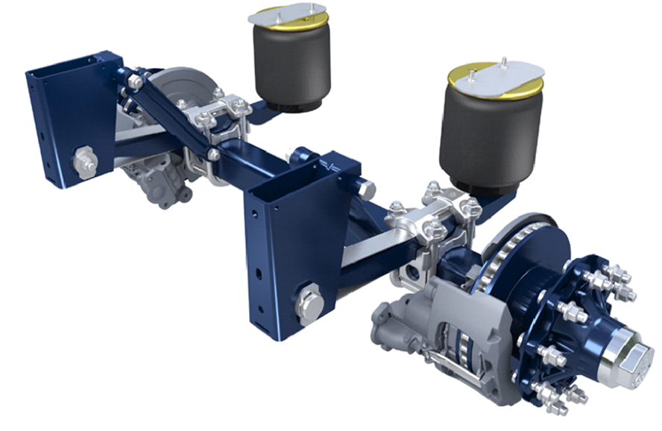

**FIG 7.2 AIR SUSPENSION SYSTEM**

1. **BENFITS AND LIMITATIONS OF AIR SUSPENSION SYSTEM**

**BENFITS OF AIR SUSPENSION:**

**"Air suspension”**, system offers several important benefits that may be useful to drivers interested in luxury cars. The primary benefit is ride quality. Vehicles with air suspension are often said to "glide" over bumps, while traditional steel spring suspension can cause a harsher ride. Also, air suspension is often adjustable. That means drivers can select a cushy ride if they are on a rough road or a harsh ride if they want to improve handling.

Another big benefit is that SUVs or trucks with the feature boast improved towing capabilities. In most of these SUVs or trucks, drivers can increase firmness when towing to account for heavier loads. That's not true of SUVs or trucks with spring suspension, where large loads can weigh down the vehicle.

**LIMITATIONS OF AIR SUSPENSION SYSTEM:**

While air suspension may be tempting, there are two downsides, both relating to cost. One is the cost of buying it in the first place. In most vehicles -- even luxury models -- it comes at an extra cost. Only very high-end cars and SUVs such as the Mercedes S-Class and the Range Rover include it as standard. In other cars, it can be an expensive option.

The Chevrolet Tahoe, for instance, offers it, but you have to upgrade to the luxury-trimmed LTZ model to get it. That means spending more than

33, 77, 550 INR–9, 21,150 INR more than the Tahoe's base price.

For shoppers interested in a used car, the bigger drawback of the feature is maintenance costs. While air suspension is great when it works, it can be expensive to fix. And it's not a feature you can simply forget about: If it breaks, the car can tilt to one side while moving. That said, many drivers replace broken systems with more traditional steel springs -- a cheaper fix, but one that removes an important feature from the vehicle.

**9.CONCLUSIONS**

**CONCLUSION:**

1. Air suspension is today mainly feature for luxury vehicle . It offers a lot of feature for compact class. Integration & smart design is key. The Air Suspension System has ability to change the load carrying capacity simply by changing the air pressure.
2. From the whole discussion in air suspension system, We observe that the system is like a white blood cell .As white blood cell provides energy to our body to fight against diseases or viruses which try to destroy or try to decrease our life ,in the similar way air suspension system provides the energy to a vehicle to protect itself from damaging, increasing life of the vehicle ,increases the handing , increases comfort of passengers and many more.
3. We conclude that a new car that offers optional air suspension, be sure to test drive models with the feature and without it. That way, you can decide if it's worth the added cost. If you're looking for a used car with it, be sure to get a mechanical inspection before signing the papers. Note, however, that even a well-inspected system can break as it ages, so you'll want some room left in your budget for a repair if it's necessary.

**REFERENCES:**

1. **“Book of vehicle suspension control systems”** by

Author 1: HonghaiLui,Author 2: Huijungao and Author 3: ping li.

1. **“NATEF Standards Job Sheets Area”** by

Authour1: JackErjavec, Author 2: Ken Pickerill

1. **“Car Suspension and Handling”** by

Author 1: DonaldBastow, Author 2: Geoffrey Howard,

Author 3: John P. Whitehead

1. **“Tires, Suspension, and Handling” by**

Author 1: John C. Dixon

1. **“Automobile Engineering”** by

Author 1: Dr.Kripal Singh

1. Aburaya, T.; Kawanishi, M.; Kondo, H.; Hamada, T**. "Development of an electronic control system for active suspension "**, Decision and Control, 1990. Proceedings of the 29th IEEE Conference on, on page(s): 2220 - 2225 vol.4.
2. Hyunsup Kim; Hyeongcheol Lee **"Fault-Tolerant Control Algorithm for a Four-Corner Closed-Loop Air Suspension System"**, Industrial Electronics, IEEE Transactions on, on page(s): 4866 - 4879 Volume: 58, Issue: 10, Oct. 2011.
3. Donggil Ha; Hyunsup Kim; Hyeongcheol Lee **"Height sensor fault diagnosis for electronic air suspension (EAS) system"**, Industrial Electronics, 2009. ISIE 2009. IEEE International.
4. Inseob Jang; Hyunsup Kim; Hyeongchul Lee; Sangsoo Han **"Height control and failsafe algorithm for closed loop air suspension control system"**, Control, Automation and Systems, 2007. ICCAS '07. International Conference on, on page(s): 373 – 378.
5. Hyunsup Kim; Hyeongcheol Lee **"Height and Leveling Control of Automotive Air Suspension System Using Sliding Mode Approach"**, Vehicular Technology, IEEE Transactions on, on page(s): 2027 - 2041 Volume: 60, Issue: 5, Jun 2011.
6. **“BPW air suspension manufactures”.**
7. **“Swathi’s Industries”.**